Congratulations!
You are going to be a BTBA Softball Coach
in the Emerald Necklace League

First Steps
After tryouts, Meg English will assist coaches at all age levels in assigning players to teams. Once you have your roster,
- Call the parents and team members. Some coaches like to speak with the players and others like to speak with the parents. This is your decision as a coach.
- Send out a welcome email and schedule a parent meeting and/or first practice. Fall practices are not mandatory, but can be helpful if you would like to get to know your team and parents before the season starts.
  - Do your players have the correct equipment? ASA approved helmets, ASA approved bats, face mask?
  - Check your paperwork.
    - Are both sides completed?
    - Did parents sign the waiver?
    - Did volunteers sign a waiver?
- Get a commitment deposit of at least $200 from each player within the next 2-4 weeks. Checks should be made out to “C.V.Y.O.” This stands for Cuyahoga Valley Youth Organization. Collect the checks at the parent meeting or have them mailed to your house.

BTBA
Having the support of the BTBA, your fellow coaches, and the community is incredibly helpful when working with a travel softball team. Meg is a great resource and offers as much guidance as needed to coaches. The monthly meetings provide valuable information and are as beneficial as the coaches make them – the more coaches who attend and actively engage, the better! Manager meetings are held each month the first or second Monday of the month. E-mail notice will be sent to all managers and Board Members.

Beginning in 2020, the BTBA softball coaches are holding separate coaches meetings for the softball coaches to learn from one another and work together.

Emerald Necklace
The Emerald Necklace website is www.emeraldfastpitch.com. Each coach should register themselves to receive complete access to the site. Schedules are listed here as well as the game results that must be entered by a coach.

The bases for softball are 60’. The pitching distances for softball are:
- 10U: 35’
- 12U: 40’
- 14U-18U: 43’
ASA Insurance
All BTBA and Emerald Necklace softball teams are required to have insurance. RegisterUSASoftball.com is the online membership website for USA Softball. All head coaches will complete a background check, ACE training, SafeSport, and concussion training as part of the insurance process. Emerald Necklace requires that all coaches in the dugout or on the field be insured. If adults are identified as coaches on the insurance roster, they will also require a background check and concussion training.

The insurance season is September 1 to September 1 each year. The 2020 season will begin on September 1, 2019 and end on September 1, 2020. Teams should have insurance prior to practicing. Players and coaches can be added to the insurance roster at any time so there is no need to wait for final rosters, coaches, or individual coaches to complete their certifications to begin the process.

Go to the RegisterUSASoftball.com and create a login. This is the place where you will register your team, watch coaching videos, and sign up for team insurance.

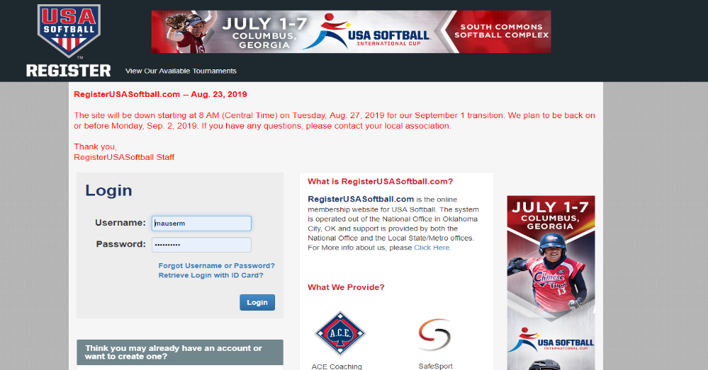

Once you create an account, here is what you will see:

Start with the Background Check. You will have to pay for this and wait until your background check clears (usually within 24 hours) before you can start your ACE Education classes.

After your background check clears (they will notify you with an e-mail or you can login to your account), then start your Ace Education Training courses.

Once your courses are complete, you are then permitted to register your team & purchase insurance.
- To register your team, select the “Add Team Button”
- Complete the Form and Add each player to your roster.
- You will need to enter each player’s DOB & Address, so have your forms handy!
After your team is entered, purchase the insurance for your team members. Select “League Team, $250 deductible, non-photo” option. Ask Tom Williams to send a check to ASA Softball for the amount on your invoice.
* Keep a copy of this paid invoice…you will need it when you register for tournaments!

Concussion Training
All coaches must complete concussion training. One recommended option to complete the requirement is www.headsup.cdc.gov. It is a free, online course. The completion certificate will need to be submitted to ASA insurance.

Lindsay’s Law
Lindsay’s Law went into effect in 2017. In accordance with this law, the Ohio Department of Health, the Ohio Department of Education, the Ohio High School Athletic Association, the Ohio Chapter of the American College of Cardiology and other stakeholders jointly developed guidelines and other relevant materials to inform and educate students and youth athletes participating in or desiring to participate in an athletic activity, their parents, and their coaches about the nature and warning signs of sudden cardiac arrest (https://odh.ohio.gov). There is a required video for coaches and handouts for players and parents.

The Ohio Department of Health website has the Required Signature Form available for download. All players and parents must sign this form and the coach is required to keep the signed forms in their team records.

Uniforms
Each team is permitted to select their own uniforms as long as they stay within the black/red/gold color scheme of the Brecksville Bees. Coaches can manage the uniform process or assign this project to volunteer parents.

Teams may purchase uniforms from any retailer. In Brecksville, Star Sports has a history of working with the BTBA and already has our tax-exempt forms on file. They will also allow players to try on uniform samples prior to ordering to ensure that the uniforms will fit correctly.

Within each age division, coaches may decide to coordinate uniforms to more easily allow players to be called up or for teams to combine for non-Emerald Necklace tournaments. Coaches should order extra jerseys should they need to call up players from another BTBA team that does not have the same uniform.

Player Equipment
Most teams do not require the purchase of team bags but that is at the coaches’ discretion. Some players already have bags and having them as an optional purchase is practical.

Batting helmets are required to have an attached face mask but the style and color of the helmets are also a team decision. Some teams all have matching helmets but others do not. BTBA provides Brecksville Bees decals to each team to add to the helmets. At the younger ages matching helmets may be more of a challenge due to the drastic size difference in players. The most important aspect is player safety and fit.

All players are required to wear face masks in the field, especially at the younger ages. The masks are available to any sporting goods store and Amazon. As with batting helmets, the priority is safety so each player needs a mask that fits and they are comfortable in.

Team Budget
Each coach is responsible for the management of their team budget. Tom Williams, BTBA accountant, will process all deposits and submit checks at the coaches’ request. His email address is smokeyoak@roadrunner.com and his mailing address is 4728 Townsend Road, Richfield, OH 44286. Tom’s telephone number is 330-523-7075.

Each manager is responsible for submitting a team budget for approval for approval by October 1ST each year. In addition to uniforms, tournaments, and practice facilities (not including Brecksville fields) sample of mandatory annual fees are:

- $250 BTBA annual fee (used for expenses relating to running the BTBA, accounting fees, checking fees, insurance, office supplies, special projects, etc)
- $180 BTBA Special Project contribution
- $55 per player fee to the City of Brecksville
- $90 Emerald Necklace umpire cancellation fee (refundable or can carry over to next season if unused)
- $300/$335 Emerald Necklace Team fee
  - 10 - 12 - $300 fee + forfeit fee
  - 14 – 18 - $335 fee includes forfeit fee
- $25 field rental fee per game on Brecksville fields
- Umpire fees per game will vary based on age and community
  - 2020 Brecksville umpre fees are
    - 14 & up (2 umpires) $50 per umpire
    - 10 & 12 (1 umpire) $65
- ASA insurance and coaches background checks
- $200 high school clinic for younger teams

Funds should be deposited to the BTBA for at least ½ budgeted amount by October 15th. Balance must be deposited prior to field allocation.

Each coach has the choice of paying for team purchases out of pocket and getting reimbursed or asking Tom for a check for an expense. For example, Tom usually mails a check with the insurance invoice but coaches may purchase team equipment and get reimbursed. Funds can be disbursed by written request. Please include a breakdown of expenses and receipts whenever feasible.

Umpires are paid in cash at each game. Coaches can request a check advance from Tom at the beginning of the season to have cash ready for each game.

Tom Williams can provide a team account statement at any time during the season and he will provide an end of year statement in August that each head coach must approve.

Head Coach Responsibilities
Meg must be notified of the following:
- Injury to player, Coach, or fan (incident report incident report must be filed with the Emerald Necklace)
- Ejection of player, coach or fan
- All damage to facilities (home or away)
- Release of player from roster.

Notify in the following manner:
- Phone call or E-Mail day of event or first thing next morning
- Written Report – Within 1 Week – Include details of event and any post event actions. Managers and players are expected to comply with all league rules. Discipline issues will be complied with regardless of whether it is a league game or out of league game. The BTBA demands good sportsman like behavior at all times.

Field Scheduling
Field scheduling is done through Meg and varies with the time of year.

In the fall, coaches are expected to ask Meg for the specific dates and time they would like to practice. If a field is available, she will schedule the practice with the city of Brecksville.

For spring practices, Meg will provide each coach with a spreadsheet of assigned field times. Each coach must confirm if they will be using the field or return the time to Meg so that another team can practice at that time.

Fields for games will also be provided electronically by Meg prior to the Emerald Necklace scheduling meetings. If a field is needed on a specific date and time not on your team list, contact Meg to determine if there is one available. Coaches are also welcome to trade their assigned field times with other coaches but must let Meg know the current assignments.

Umpiring Fees and Rainout Procedure
Home team coaches are responsible for notifying their own team, the opposing team, and the umpires if a game is rained out or moved. If the umpires show for a game you will be responsible for paying the umpires!

For Brecksville home games:
- TEXT 84483 – BRECKREC – to be added to Brecksville text rainout notification.
- The Brecksville field rainout number is 440-526-8772 –DO NOT give this number to players or other city’s coaches. This number is updated for all games and practices.

Fees are to be paid directly to the umpire at time of game – vouchers are not acceptable.
Coordinator (Meg) will schedule umpires for the master schedule. Each manager is responsible for scheduling umpires for any changes in the master schedule.

Emerald Necklace umpire contact:
- Phone 216-362-2816 (Beth)
- Fax: 216-362-2833
- Email: suauic@yahoo.com
Soliciting Donations
Approval must be received PRIOR to solicitation of ALL donations. All donations must be made payable to BTBA. A determination must be made prior to solicitation of fund intent.

EXAMPLES:
- If a solicitation is made from Joe’s Uniforms because all teams purchased uniforms from them, then a donation from Joe’s uniforms should be distributed among all teams.
- If a team receives a donation because of a direct relationship then those funds should be given to specific team as the relationship dictates. However, prior approval is still mandated to document solicitation.

Complete information is required for all donations. The BTBA is required to show support from donations as part of the requirements for tax free status. Additionally, certain donations may require additional action on part of the BTBA. In addition to legal requirements the BTBA wants to properly acknowledge donations.

All fundraisers must have prior approval by the Board of Directors.

